**Create Node-RED Service**

|  |  |
| --- | --- |
| **Date** | 18 November 2022 |
| **Team ID** | PNT2022TMID06176 |
| **Project Name** | GAS LEAKAGE MONITORING AND ALERTING SYSTEM |
| **Batch Members** | Vishnu V  Gunaseelan D  Manojkumar S  Sanjai S |

**Aim**:

To create a web application, create a Node-RED service.

# Steps to be followed

Step 1: Navigated to the App creation page.

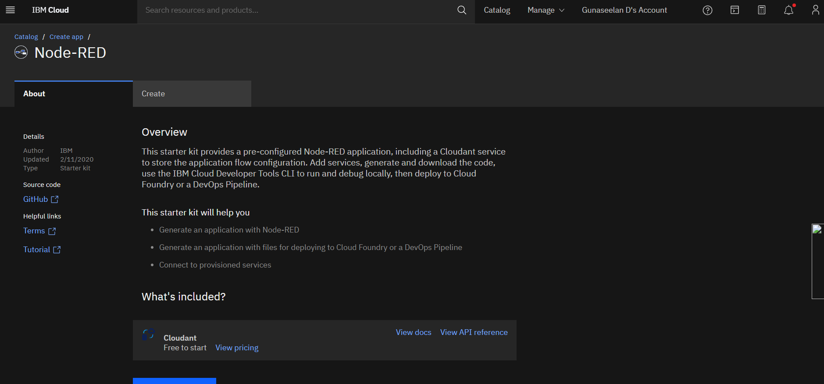

Step 2: Entered project details and clicked on create

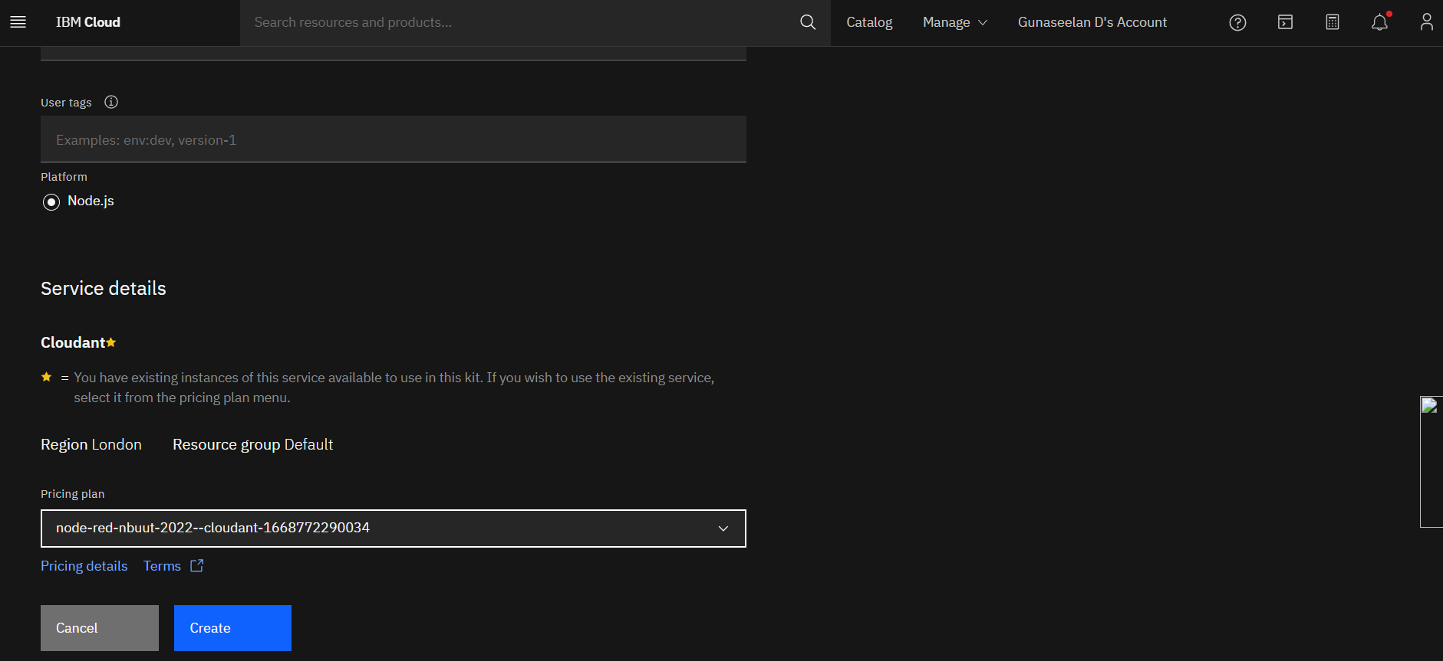

Step 3: Clicking on the “Deploy your App” Button.

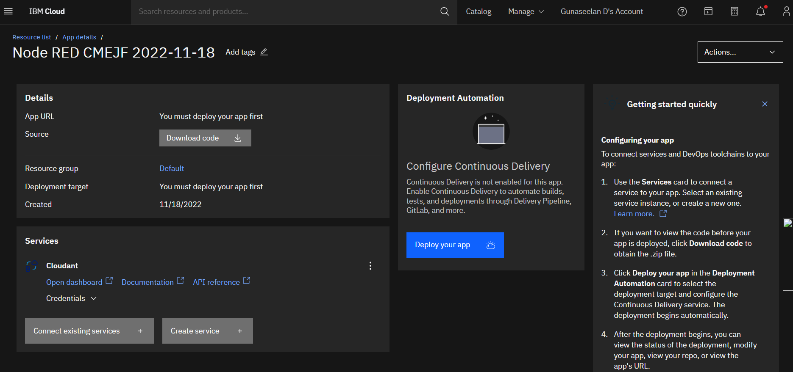

Step 4: Setting up the environment and deploying the app.

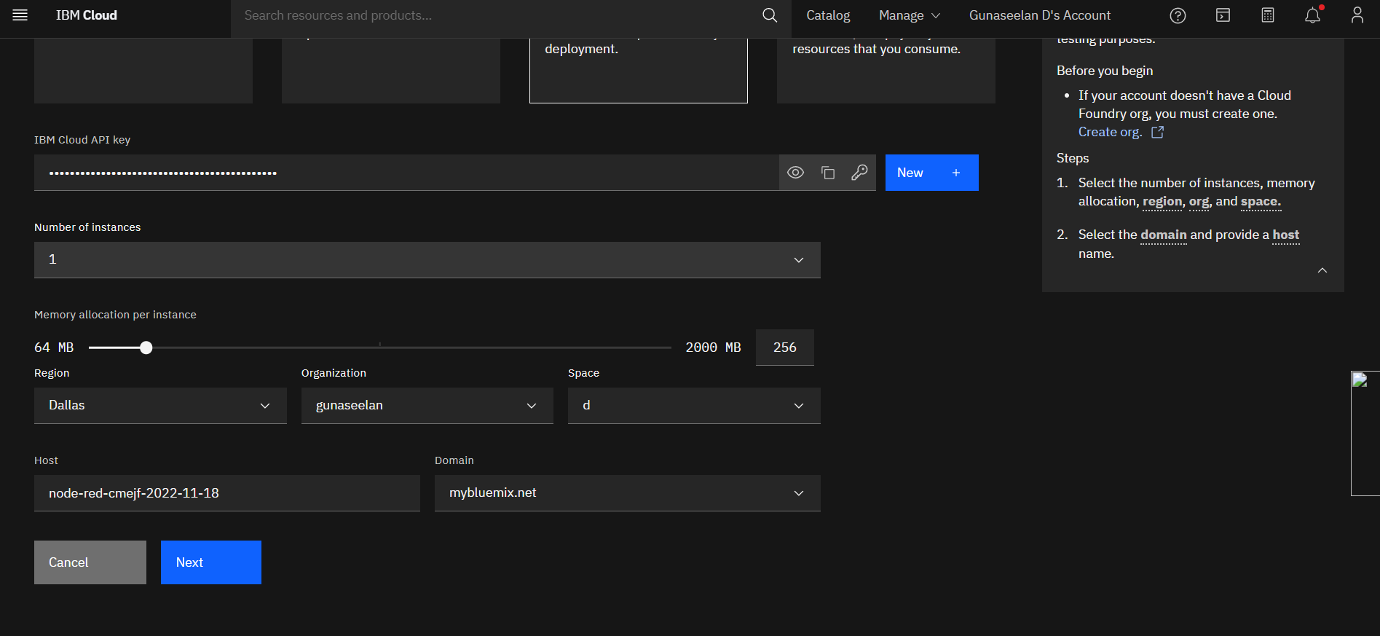

Step 5: Successfully deployed the app.

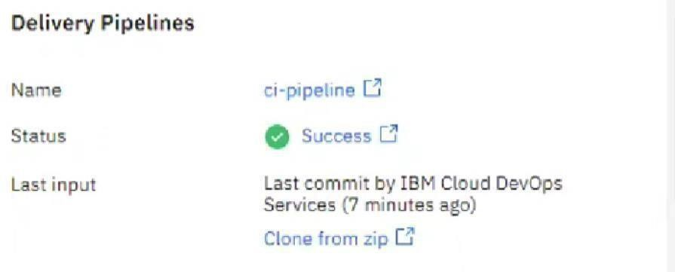

Step 6: Dragged and dropped components into the editor.

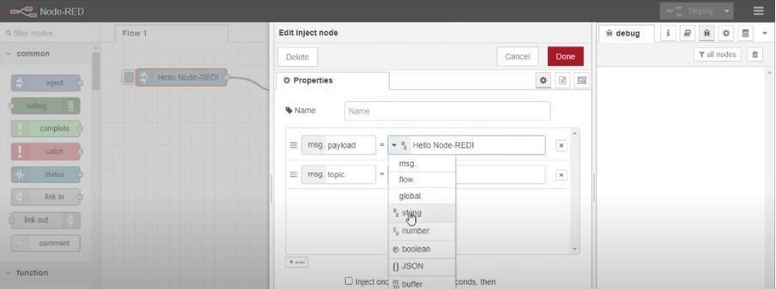

Step 7: Editing some values of the properties.

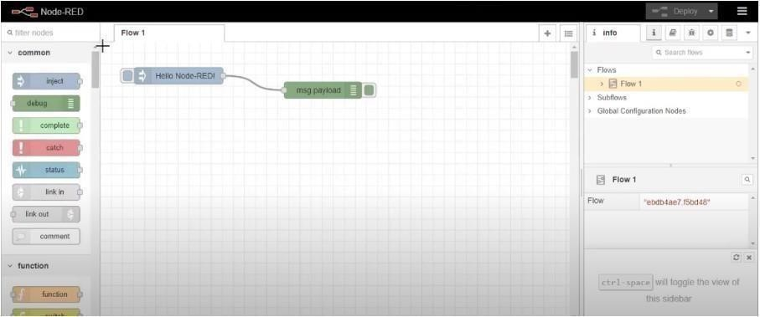

Step 8: Successfully deployed the app.

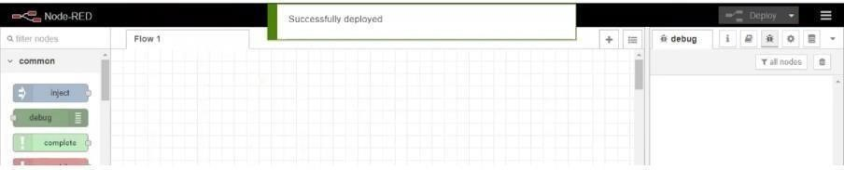

**Result:**

Successfully created a Node RED service on IBM Cloud.